5 in 1 Dimmable JUNCTION Box LED driver
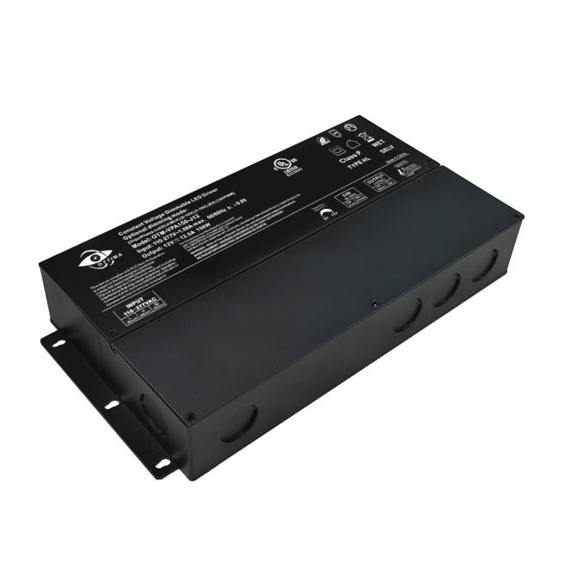
Triac/0-10V/1-10V/Potentiometer/10V PWM

Features:
·Output constant voltage
·UL cUL listed, Class 2, Class P, Type HL, FCC, NEMA 4X, CE, RoHs
·Universal input, 110-277Vac
·Build in active PFC, typical power factor>0.95,
·THD<20%@120V Max. load
·High efficiency : up to 90%
·Load: 0.01-100%
·Short-circuit, over-temperature, over-load protection
·Full protection metal case, for dry, damp, wet location
·Flicker-free
·Suitable for LED lighting and moving sign applications


Product advantage：
•Dim-all: Triac/0-10V/1-10V/10V PWM/Potentiometer
•Switch to PWM or Voltage Reduce output
•Dimming effect:
•Voltage Reduce mode: 100%-0.01% dim, stepless dimming,flicker-free,
•PWM dim mode:100-0.1% dim, flicker-free
•Triac dim mode: Forward phase & reverse phase, MLV, ELV dim
•Exclusive patent design of “Clamshell” junction box,low-profile logo
•Flexible wiring compartment to adjust the AC and DC wiring space
•Metal shell NEMA 4X for indoor and outdoor use; Wet, damp, and dry location
•Title 24 JA8 compliant
•Constant voltage type, fine tune of output voltage
•Super low loading request, works perfect at 0.01-100% load.
•7 years warranty
•Dimming range: 100%-0.01% Ultra Deep Amplitude
•No Vpeak-peak during driver on/off and dimming, no harm to the LED for long-term using, and slow down the •speed of lumen depreciation.
•Works with single channel CCT warm-dim LED strip/tape (2 wires).
•Switching different output mode, can be compatible with more different types of LED lamps
•Compatible with DC-DC design LED fixture, such as MR16, PAR, wall washer, linear lighting, LED strip/type

■ Specification
Model |  | SL-TR-DEM150W-12V |  | SL-TR-DEM150W-24V | SL-TR-DEM150W-36V | SL-TR-DEM150W-48V
Certificates |  | UL, cUL listed, Type HL rated, FCC NEMA 4X
Output | DC Voltage | 12V | 24V |  | 36V | 48V
Output | Rated Current | 12.5A | 6.25A |  | 4.16A | 3.125A
Output | Rated Power | 150W | 150W |  | 150W | 150W
Output | Voltage Tolerance | ±0.5V
Output | Voltage Regulation | ±0.5%
Output | Load Regulation | ±2%  ±1% |  |  | ±1%
Input | Voltage Range | 110-277VAC
Input | Frequency Range | 47-63Hz
Input | Power Factor（Typ.） | @ full load 0.99@120VAC 0.96@277VAC
Input | THD（Typ.）@ full load | <20% @120VAC &277VAC
Input | Efficiency（Typ.）@ full load | 87% @120Vac 90%@277Vac
Input | AC Current（Max.） | 1.8A@110Vac
Input | Inrush Current （Typ.） | 15A, 50%, 1.4ms @120VAC; 30A, 50% 1.4ms @277VAC
Input | Leakage current | <0.50mA
Protection | Short Circuit | Hiccup mode, recovers automatically after fault condition is removed.
Protection | Over Loading | ≤120% Hiccup mode, recovers automatically after fault condition is removed
Protection | Over temperature | 100℃±10℃ shut down o/p voltage, automatically recover after cooling.
Environment | Working TEMP. | -40～+60℃ (see below derating curve)
Environment | Working Humidity | 20～90%RH, non-condensing
Environment | Storage TEMP. Humidity | -40～+80℃，10～95%RH
Environment | TEMP .coefficient | ±0.03%/℃（0～50℃）
Environment | Vibration | 10～500Hz, 5G 10min./1 cycle,period for 60min. each along X,Y,Z axes
Safety& EMC | Safety standards | UL8750+UL1310
Safety& EMC | Withstand voltage | I/P-O/P:1.88KVAC
Safety& EMC | Isolation resistance | I/P-O/P:100MΩ/500VDC/25℃/70%RH
Safety& EMC | EMC EMISSION | FCC Part 15 B
others | Net. Weight | 1.8Kg
others | Size | 254*132*42.5mm (L*W*H)
others | packing | 10PCS/CTN,Packing size:300*285*250mm  385*335*200mm 20PCS/CTN
Notes | 1. All parameters if NOT specially mentioned are measured at 120VAC input , rated load and 25℃of ambient temperature.  2. To extend the driver's using life ,please reduce the loading at lower input voltage.

■ Derating Curve
To extend their life, please refer to the Derating Curve and derate according to the temperature.
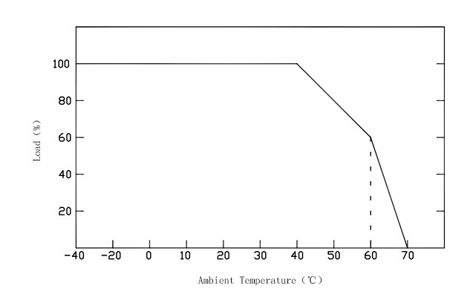

■ Mechanical Specification
Unite: mm
Tolerance: 0.5-2mm
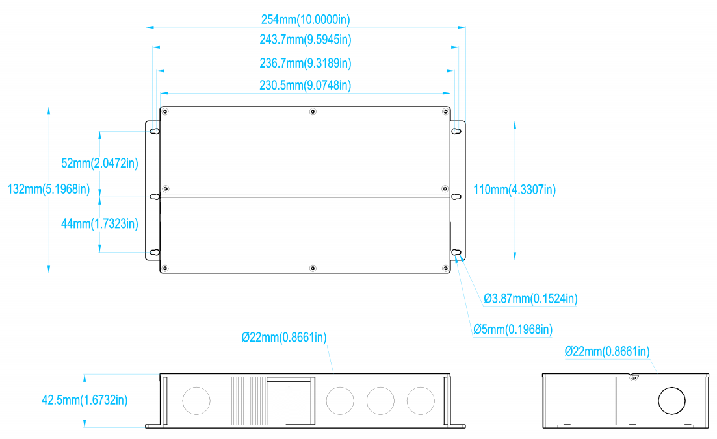

※ Input wire Black and White to be connected to AC L and N ,Green wire go ground,
※Output wire Red to LED Positive side (+) , Black to LED Negative side (-).
※Dimming cable DIM (+) Purple to 0/1-10V dimmer signal(+ ),DIM (-) Pink to 0/1-10V dimmer signal (-)
※Please make sure your connect these correctly otherwise your product will not function correctly and could be damaged.
※Note: Any other requests we can customized.

■ Connecting Diagram
※Using TRIAC/Phase cut dimming
1.The Pulse-Width Modulation (PWM) of output voltage can be adjusted through input terminal of the AC phase line(L) by connection a phase /Triac dimmer of lighting system.
2.Work with forward phase /leading edge ,MLV and reverse phase /trailing edge ,ELV,TRIAC dimmers.
3.Please try to use dimmers with power at least 1.5 times as the output power of the driver.

Using Triac MLV wiring diagram
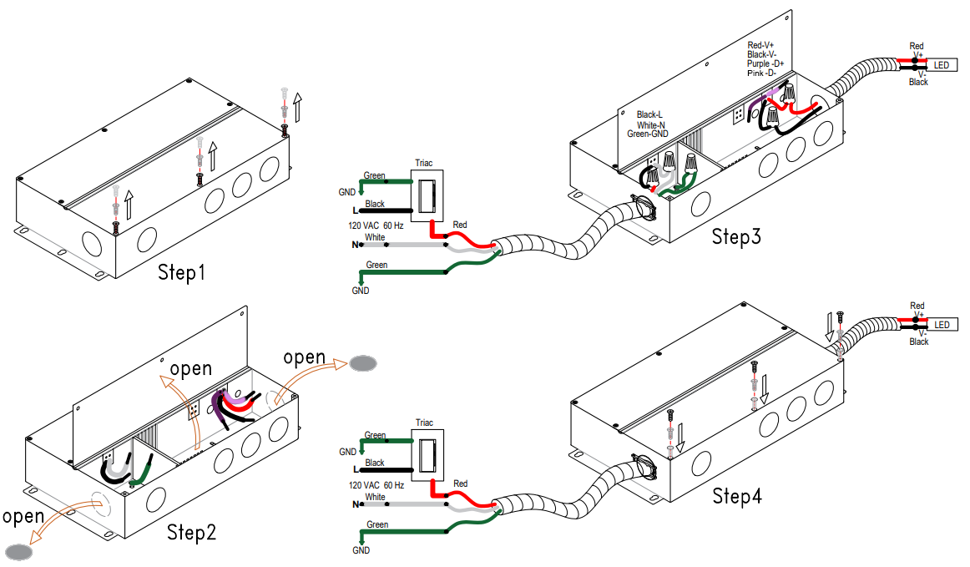

Using Triac ELV wiring diagram
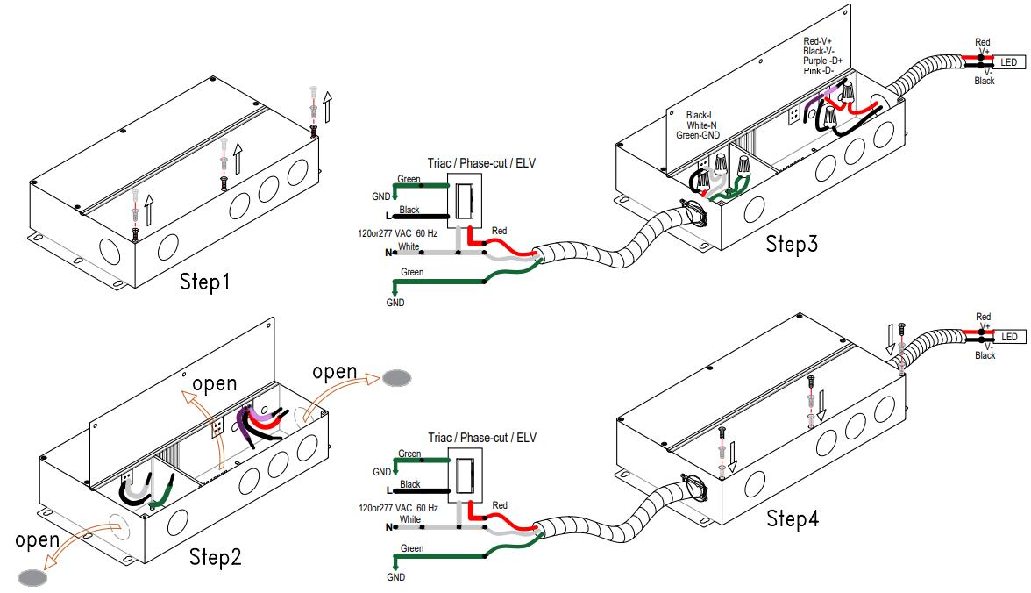

※Using 0-10/1-10V dimming (The power supply does not pass through the dimmer)
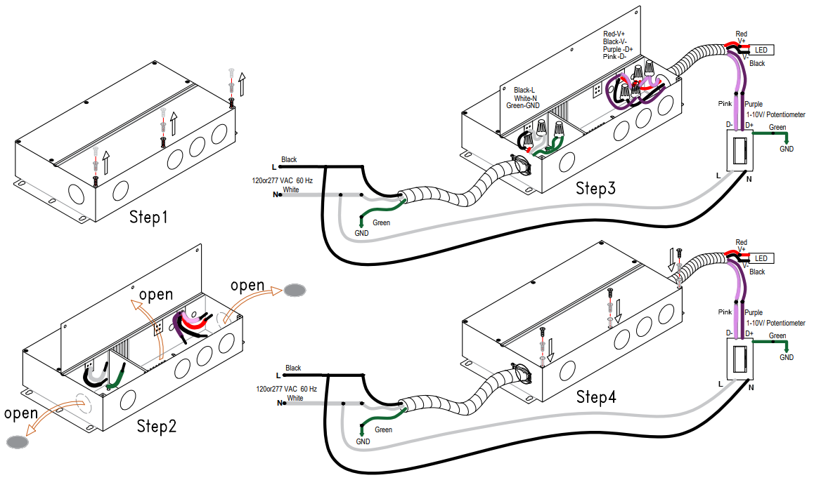

※Using 0-10/1-10V dimming(Power supply through dimmer switch)
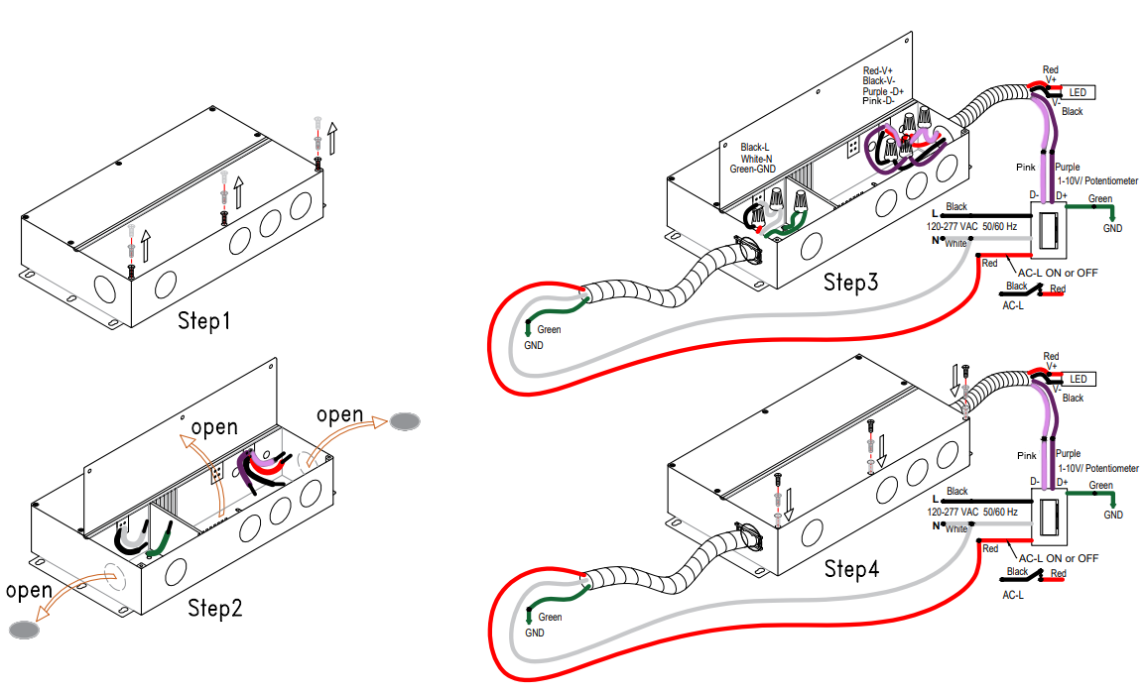

※Using 0-10/1-10V dimming(The dimmer is not connected to high voltage)

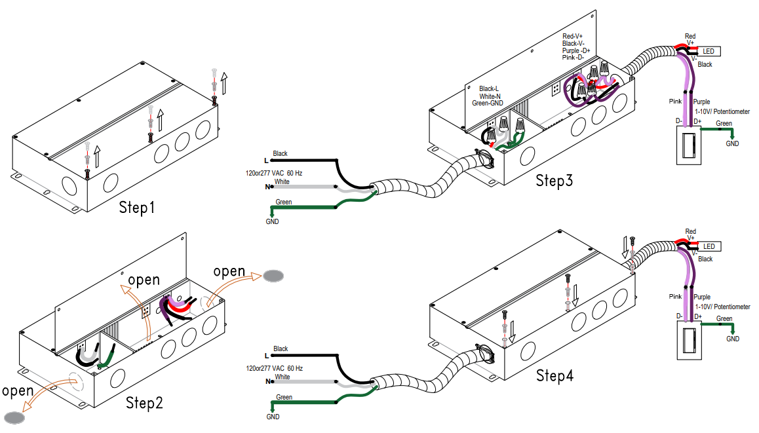

※The topology
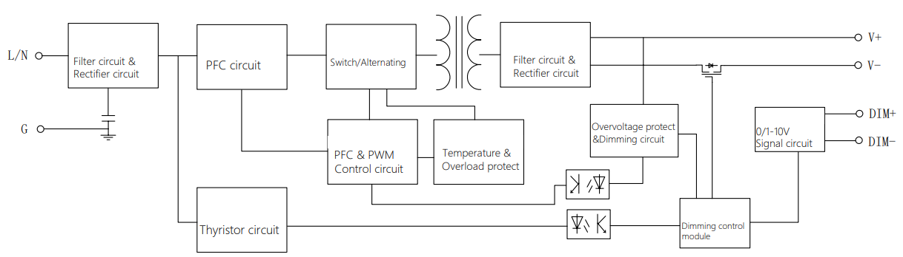

※PFC load graph
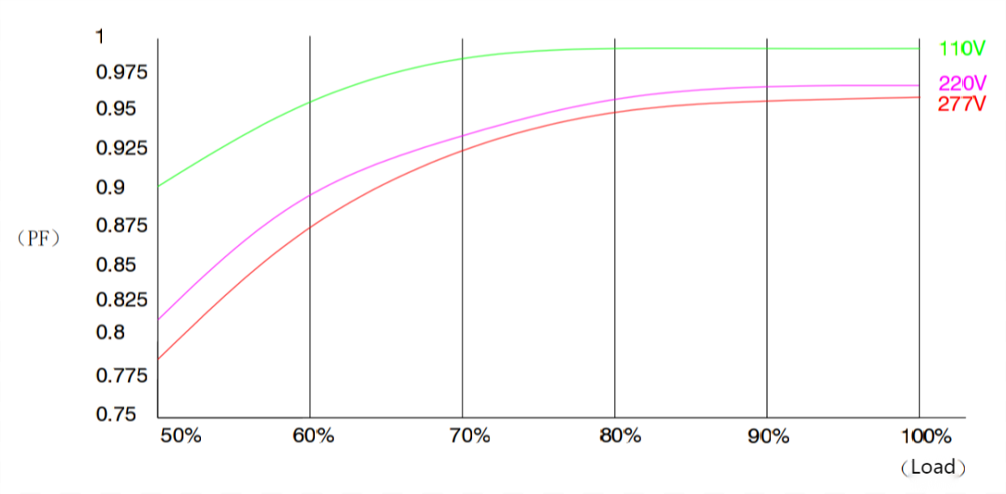

※PWM dimming curve ※VR dimming curve

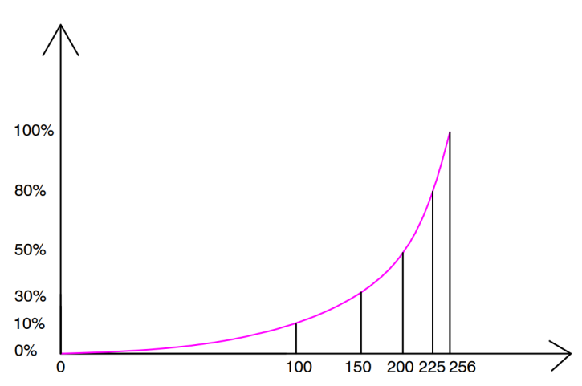
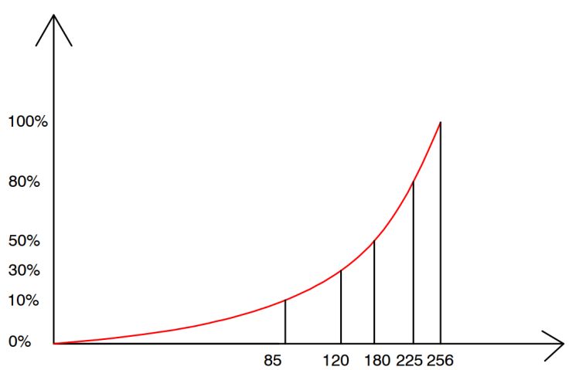

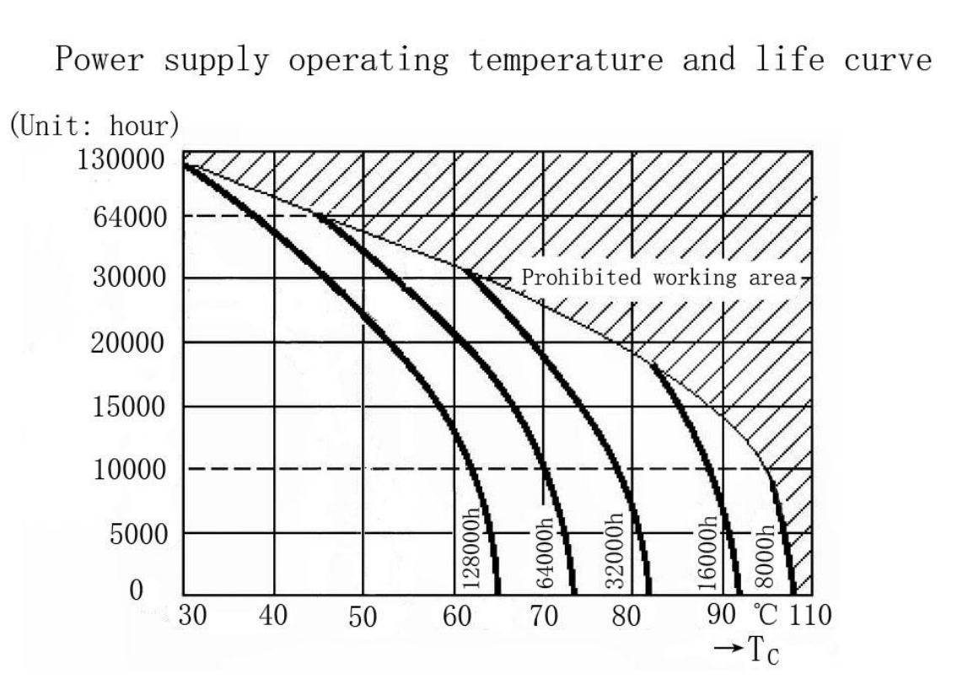
■ Instruction:
- This driver should be installed by qualified and professional person;
- Please make sure the driver is installed with adequate ventilation around it to allow for heat dissipation.
- Ensure that wiring is correct before test in order to avoid light and power supply damage;

